CEG 4166 – Real-Time Systems Design
Laboratory 4: Real-Time Face Recognition on the Stingray

Winter 2025
University of Ottawa
Faculty of Engineering, School of Electrical Engineering and Computer Science
Section 2
TAs: Devansh Kumar, Kamran Gholizadeh Hamlabadi

Group 9
Stingray 23
Team Members:
Keith Tran – 300240028 – ktran033@uottawa.ca
Kevin Dang – 300241133 – kdang038@uottawa.ca
Saurav Guduru – 300234999 – sgudu104@uottawa.ca

Submission Date: 2025-03-21
Table of Contents
Introduction 3
Objectives 3
Background Material 3
Functionality Scope 3
Theory 3
Real World Modelling 3
Control Principles 3
Programming Concepts 3
Experimental Setup 4
Hardware Architecture 4
Software Architecture 4
Testing Methodology 4
Results and Observation 5
Discussion 5
Challenges 5
Solutions 5
Results 6
Future Recommendations 6

Introduction

Objectives
The objectives of the laboratory are as follows:
- Implement facial recognition model that can detect and identify an individual based on their face

Background Material
This lab builds upon the previous lab by implementing a facial recognition model using image data captured via the PiCamera.

Functionality Scope
The functionality to be implemented for this lab are as follows:
Facial capture: capture images of faces as an input
Data conversion and storage: store image input data as a .yml file
Facial recognition model: use the stored data to create a facial recognition model

Theory

Real World Modelling
This lab involves real world modelling using the camera attached on the stingray to detect faces in real time. The captured images from the camera are processed using the LBPH (Local Binary Pattern Histogram) algorithm. During operation, the system will continuously process images captured by the camera to detect faces and surround each frame in a bounding box with its confidence based on the faces in its dataset. This will allow the stingray to instantly detect and recognize facial images and display its results even when in motion.

Control Principles
The control principles in this lab mainly involve the use of threading to manage processes running simultaneously such as the face detection and recognition in real time. By using threads, it ensures that the system to process images without any delays. Using PiCamera allows us to continuously capture and process frames which is then sent to the facial recognition model. The model will analyze the frame and display a bounding box along with its confidence level on how well it thinks it matches the trained dataset.

Programming Concepts
The following are the important programming concepts used in this lab.
Multithreading and concurrency: the different functions of the robot were executed on separate threads that ran concurrently.
Object-oriented programming: subsystems of the robot (e.g. wheel movement, sensor, camera) were virtualized as objects in the code, each with their own attributes and functions and instantiated in one shared main running program.
Use of packages: python packages were imported to make use of external tools and libraries in our code. Packages were included to implement multithreading, interact with the PiCamera, and use the OpenCV library for image processing and computer vision tasks.
Machine learning model: using the camera feed, a machine learning model detects and identifies faces.

Experimental Setup

Hardware Architecture
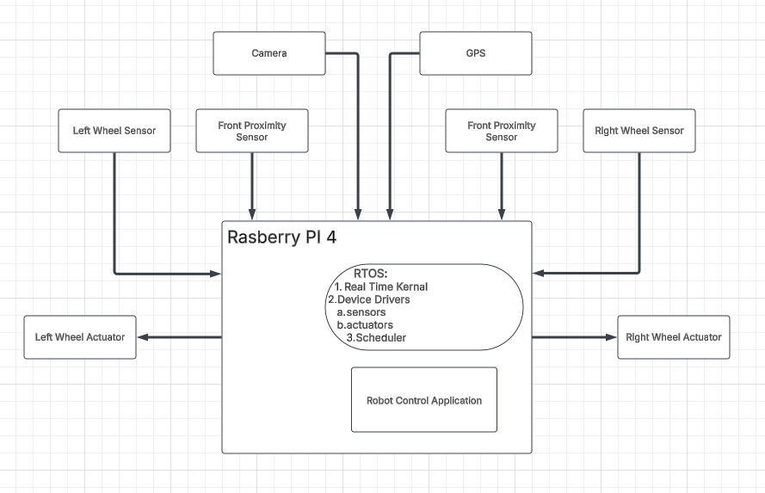

Software Architecture
The software architecture is comprised of the following program modules:
- detect_test.py: test for detecting faces via a live camera feed
- faces_input.py: software that captures live image feed, detects faces, and takes images of them, which are then saved to a database.
- final_FaceRecog.py: program that performs facial recognition; predicts individual by matching face to name in database.
- model.py: runs the face detection model.

Testing Methodology
Our methodology for testing was to first test individual components of the program at a time, then gradually test components together, before testing all the components running under one program. This was done by commenting out atomic modules of the code that were not immediately related to the specific function currently being tested.
For testing the facial recognition model, we tested it by showing each of the team members’ faces, observing if it would form a box around the face, if it was able to correctly identify the individual, and with what percentage certainty.

Results and Observation
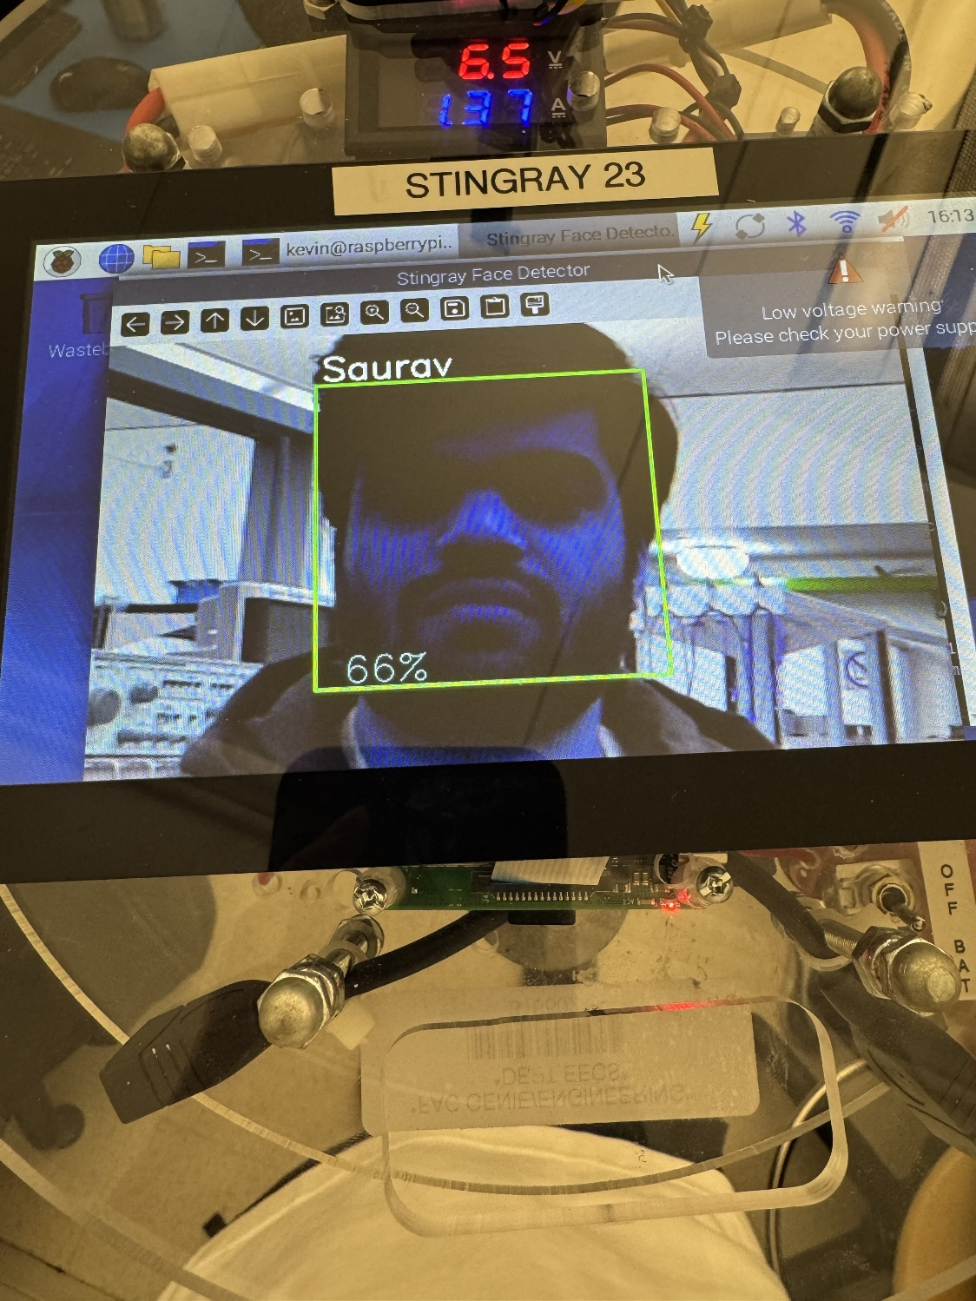
The source code for this lab can be found zipped in the file titled the following: “CEG4166_2025W_Section2_Group9_Lab4_Code_20250321-01.zip.”

Discussion

Challenges
We encountered version incompatibility between PiCamera2 and OpenCV, which caused errors in image capture and processing. OpenCV failed to recognize frames from PiCamera2, affecting real-time face detection. Additionally, installing the latest OpenCV version led to dependency conflicts, preventing proper frame reading and processing.

Solutions
To fix these issues, we referred to the official documentation, uninstalled the conflicting versions, and installed the recommended ones. Using pip install opencv-python and pip install picamera2, we ensured compatibility. We then validated the setup with test scripts to confirm that OpenCV successfully processed frames from PiCamera2.

Results
Overall, the results obtained matched with the results that were to be expected. The system was able to capture images of each of the team members’ faces, store it to a database, then predict the name of an individual based on the images saved in the database.

Future Recommendations

